Personal Finance Manager A PROJECT REPORT
Submitted by Ayush Kumar 24BEC10109


VIT BHOPAL UNIVERSITY
KOTHRIKALAN, SEHORE MADHYA PRADESH - 466114

Introduction

The Personal Finance Manager is a Java-based console application that helps users manage their financial activities efficiently. It provides comprehensive tools for tracking income, monitoring expenses, and maintaining budgets. The system is designed to give individuals complete control over their financial health through systematic organization and analysis of their monetary transactions.

Problem Statement

Many individuals struggle with financial management due to disorganized tracking methods and lack of proper budgeting tools. People often lose track of their spending patterns, fail to maintain budgets, and lack insights into their financial health. This leads to poor financial decisions, unnecessary debt, and inability to achieve savings goals. There is a clear need for a simple, accessible tool that provides financial visibility and control.

Functional Requirements

The system must include three core modules: Transaction Management for recording financial activities, Financial Analytics for spending analysis, and Budget Planning for expense control. Each module requires clear input/output structures and logical workflows. The application should handle data validation, error checking, and provide meaningful feedback to users during all operations.

Non-Functional Requirements

Performance requirements ensure the system responds within two seconds for all operations. Security measures include data encryption and input validation against injections.
Usability focuses on intuitive menu navigation and clear prompts. Comprehensive error handling manages invalid inputs, file operations, and system exceptions gracefully without crashing.

System Architecture

The system follows a modular layered architecture with presentation, business logic, and data layers. The console interface handles user interactions, the business layer processes financial operations, and the data layer manages encrypted file storage. Components include Transaction Manager, Budget Controller, Analytics Engine, and File Handler, all coordinated by the main application controller.

Design Decisions & Rationale

Console-Based Interface: Chosen for simplicity and broad compatibility across systems without GUI dependencies. File-Based Storage: Selected over databases for lightweight deployment and easier user setup. Modular Architecture: Implemented for maintainability and future scalability.
Encryption: Added basic file encryption for user privacy despite local storage.

Implementation Details

Core Technologies: Java 11, Java Standard Library. Data Structures: ArrayList for dynamic collections, HashMap for category tracking. Algorithms: Sorting for reports, encryption for data security. Key Methods: addTransaction(), calculateBalance(), generateReports(), validateBudget().

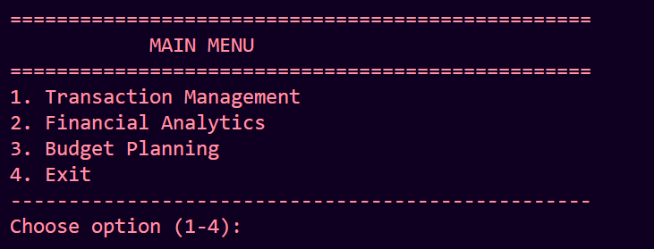
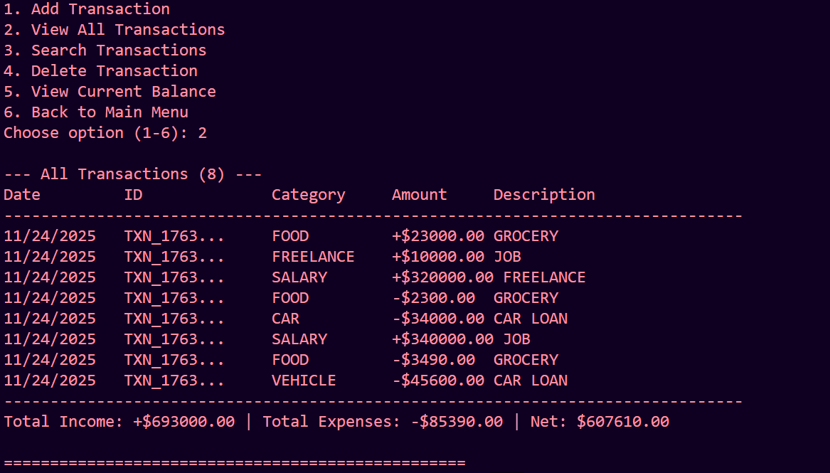
Screenshots / Results

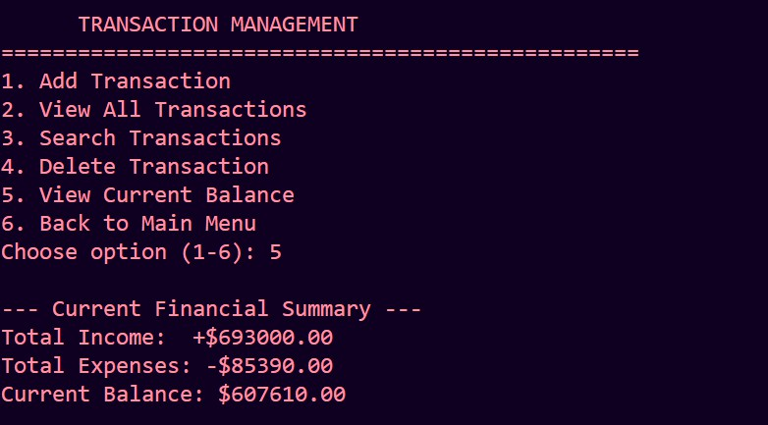

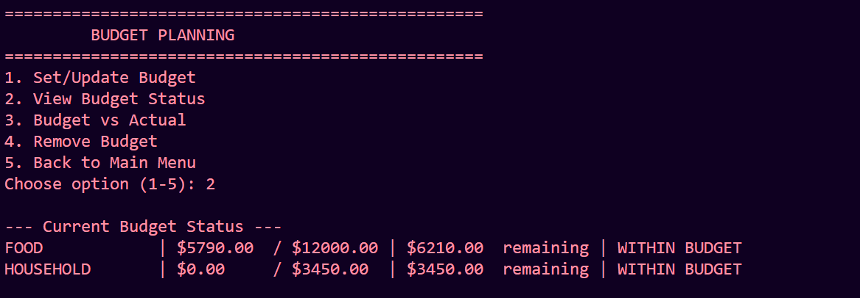
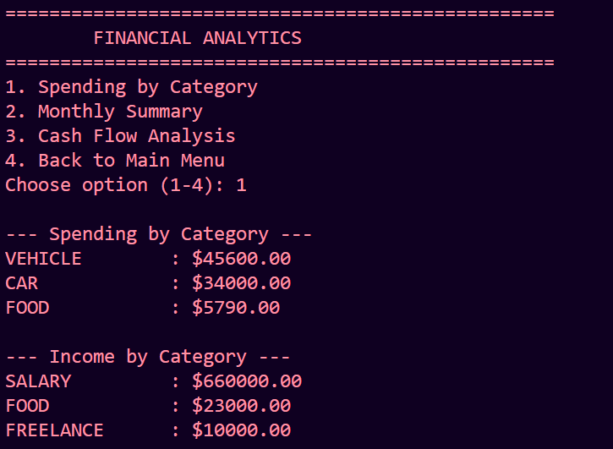

Testing Approach

Unit Testing: Individual method validation for core functions. Integration Testing: End-to-end workflow verification. User Acceptance: Real-world scenario testing with sample data. Error Testing: Invalid input handling and edge cases.

Challenges Faced

Data Persistence: Implementing reliable file handling with error recovery. Input Validation: Comprehensive user input sanitization. Budget Tracking: Real-time synchronization between transactions and budgets. User Experience: Balancing feature richness with interface simplicity.

Learnings & Key Takeaways

Software Design: Importance of modular architecture for maintainability.
User-Centric Development: Value of intuitive interfaces for non-technical users.
Data Integrity: Critical need for robust validation and error handling.
Documentation: Essential role of clear documentation in project success.

Future Enhancements

GUI Implementation: Graphical user interface for better user experience.
Data Export: CSV/PDF report generation capabilities.
Recurring Transactions: Automated periodic transaction handling.
Multi-Currency Support: International financial management.
Cloud Sync: Secure cloud backup option.

References

Java Documentation: Oracle Java SE Documentation. Financial Concepts: Personal finance management principles. Design Patterns: MVC architecture references.
Security: Basic encryption methodologies for data protection.

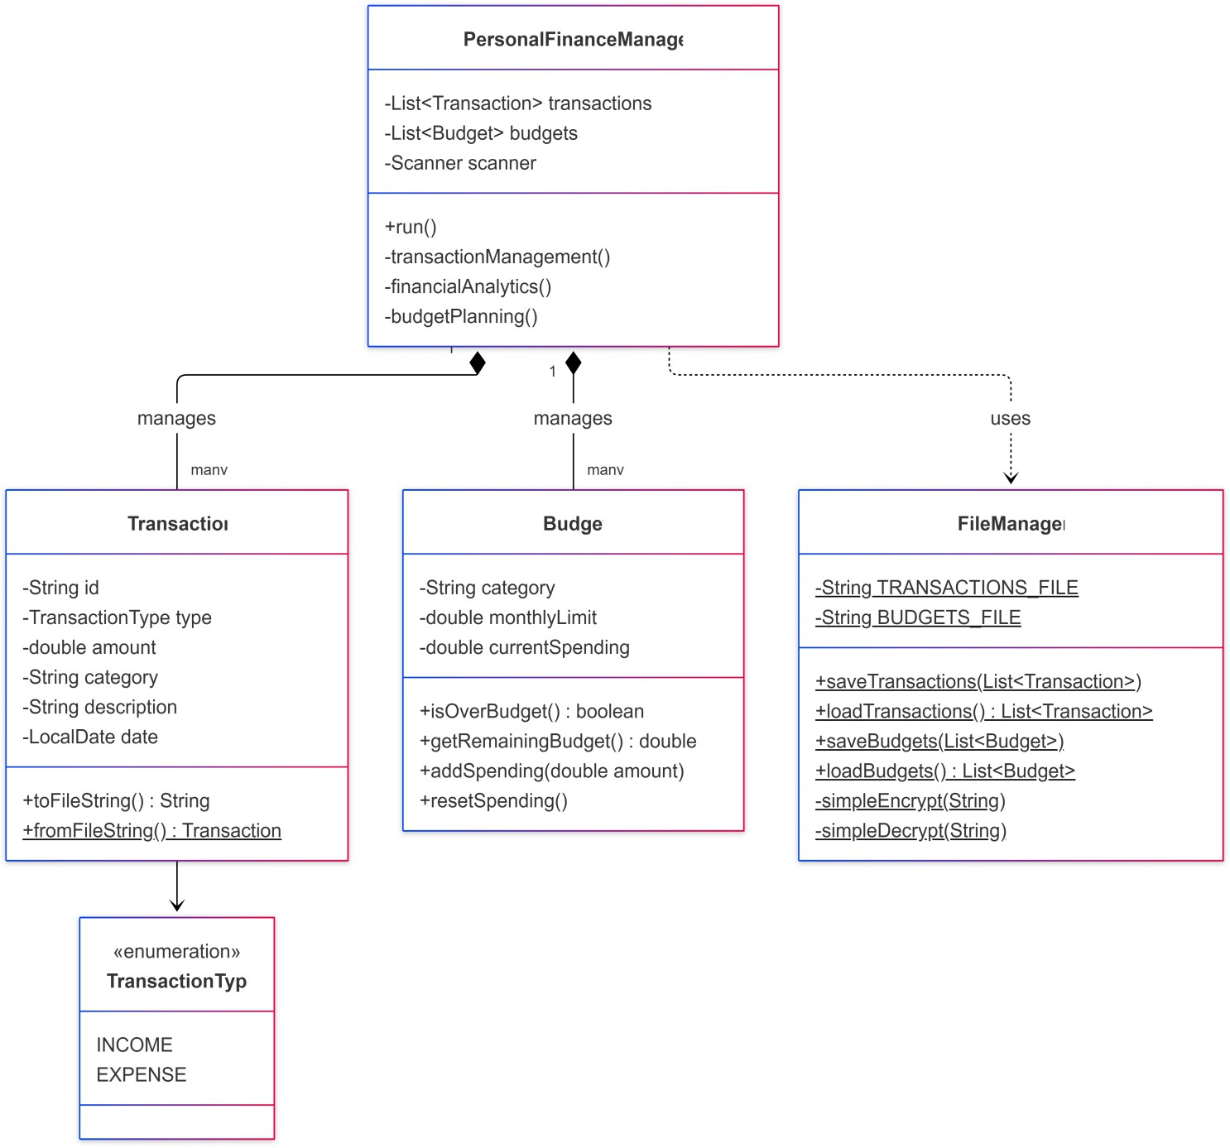
CLASS DIAGRAM

System Architecture Diagram
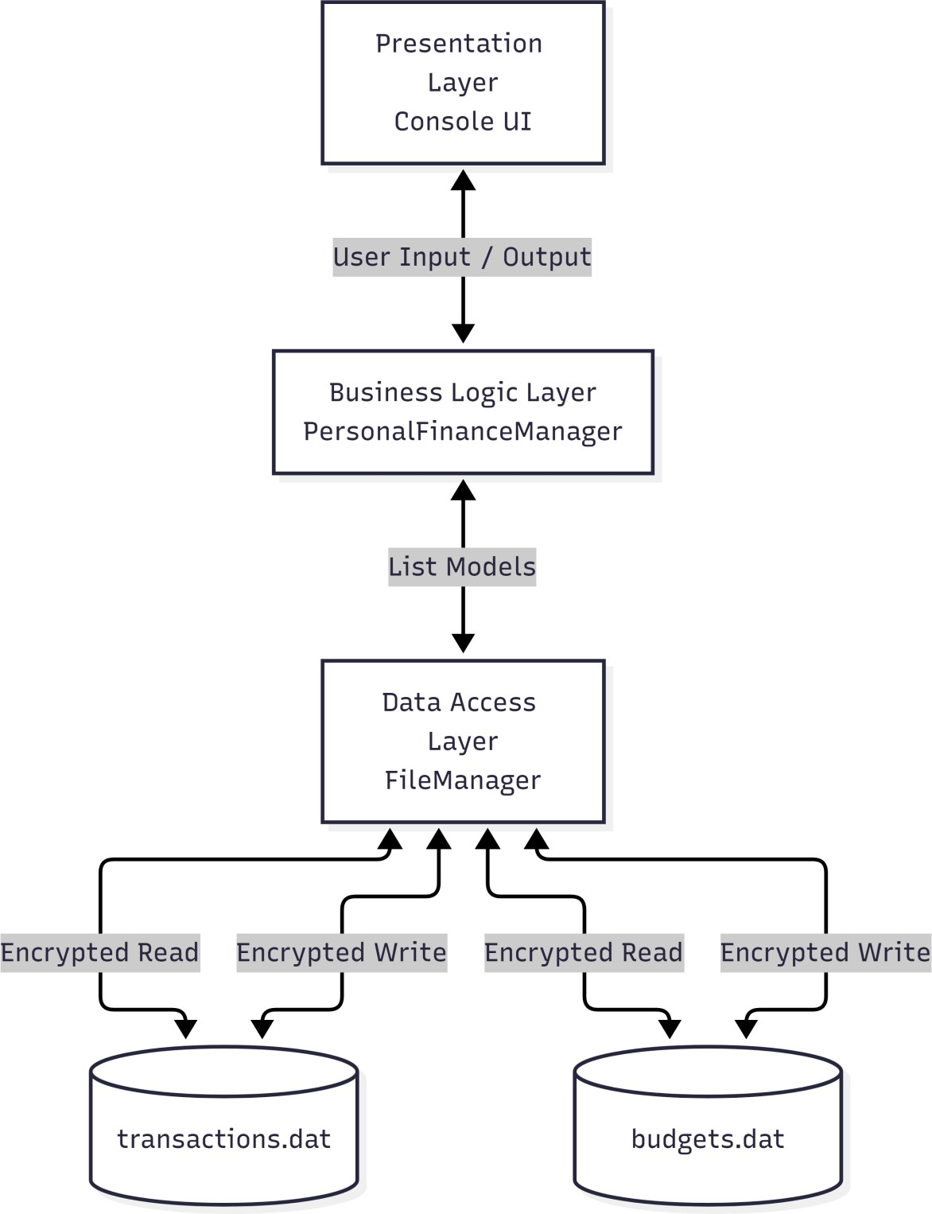

Sequence Diagram
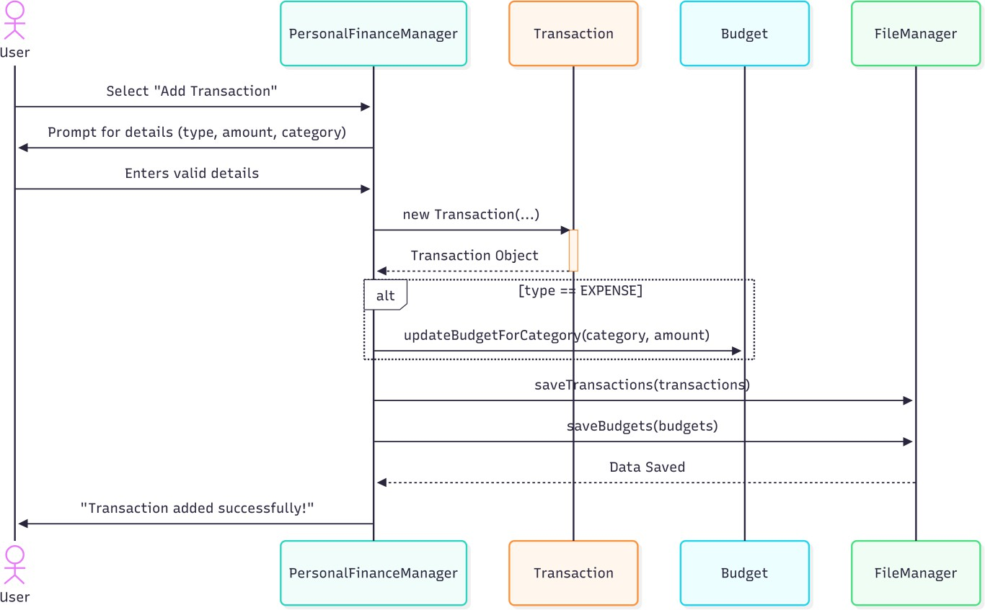

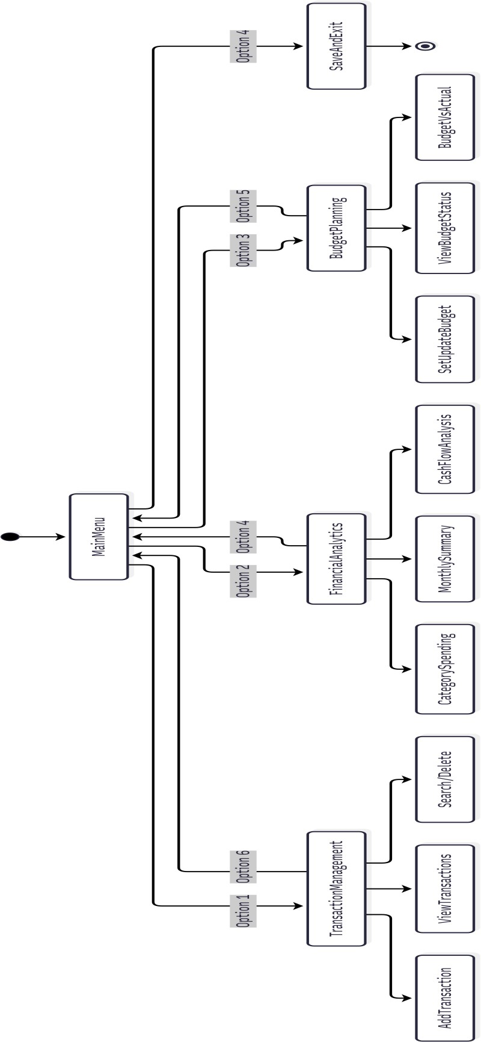
Process Workflow Diagram

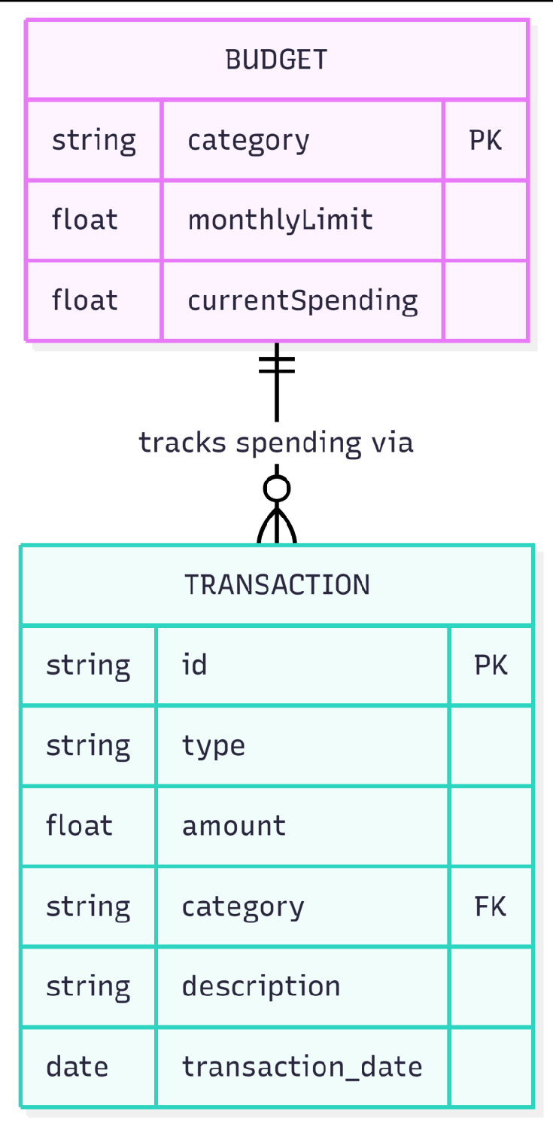
ER (Entity-Relationship) Diagram

